**Name:** Vineel Sai

**Reg No:** 498

**IIIT Kalyani, Assignment 4 8051 Micro controller**

**PROB.1** WRITE A PROGRAM TO READ AN 8-BIT TEMPERATURE IN CELSIUS FROM PORT 1 AND TO OUTPUT THE FARENHEIGHT TEMPERATURE EQUIVALENT ONTO PORT 2.

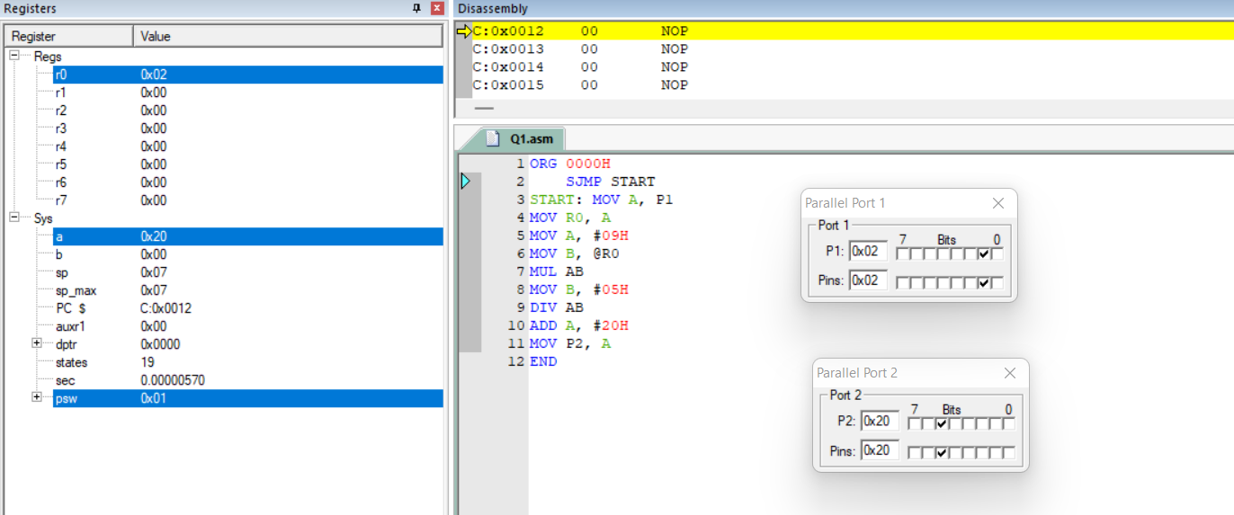

**PROB.2** WRITE A PROGRAM TO TOGGLE BIT P1.2 WITH ONE SEC DELAY.

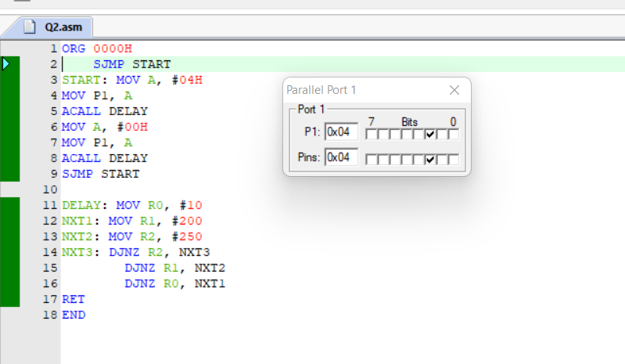

**PROB.3** WRITE A PROGRAM TO SHIFT THE BITS OF P1 ONE BY ONE IN SEQUENCE CONTINUOUSLY WITH 1 SEC DELAY.

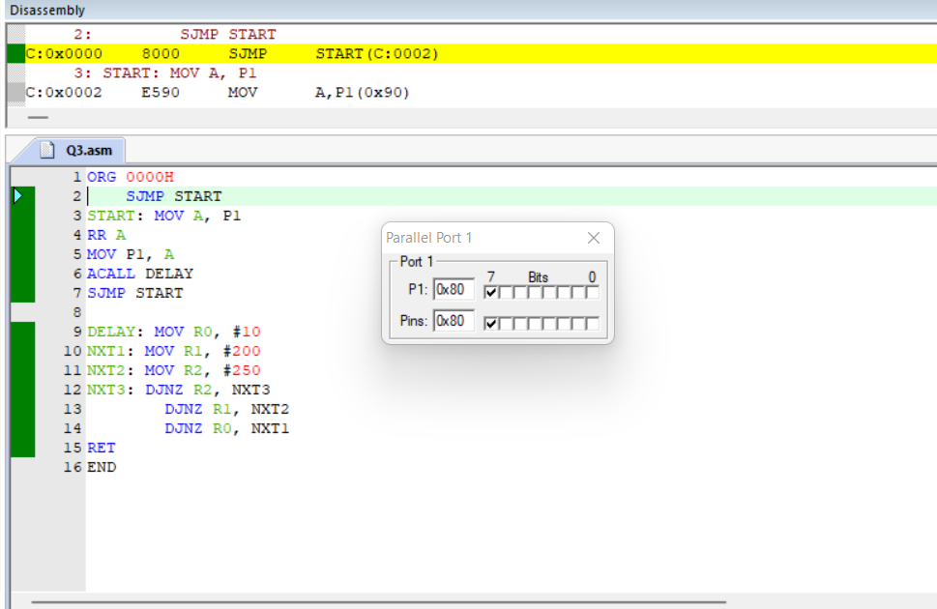

**PROB.4** IN A SEMESTER, A STUDENT HAS TO TAKE SIX COURSES. THE MARKS OF THE STUDENT (OUT OF 25) ARE STORED IN RAM LOCATIONS 47H ONWARDS. FIND THE AVERAGE MARKS, AND OUTPUT IT ON PORT 1.

